**VELAMMAL BODHI CAMPUS**

**PART TEST-II**

**Class : X** **Duration : 3.00Hrs**

**Sub : Maths -Batch -I Marks :80**

**General Instructions:**

1. This Question Paper has 5 Sections A, B, C, D and E.

2. Section A has 20 MCQs carrying 1 mark each

3. Section B has 5 questions carrying 02 marks each.

4. Section C has 6 questions carrying 03 marks each.

5. Section D has 4 questions carrying 05 marks each.

6. Section E has 3 case based integrated units of assessment (04 marks each) with sub- parts of the values of 1, 1 and 2 marks each respectively.

7. All Questions are compulsory. However, an internal choice in 2 Qs of 5 marks, 2 Qs of 3 marks and 2 Questions of 2 marks has been provided. An internal choice has been provided in the 2marks questions of Section E

8. Draw neat figures wherever required. Take π =22/7 wherever required if not stated.

**Section-A**

|  |
| --- |
| **I. Section A has 20 MCQs carrying 1 mark each.** |
| 1. If sin $θ+\cos{θ=\sqrt{2, }then \tan{θ+\cot{θ}}}$ =  a)1 b) 2 c) 3 d) 4  2. If a pole 6 m high casts a shadow 2 $\sqrt{3}$ m long on the ground, then sun’s elevation is:  a) 600 b) 450 c) 300 d) 900  3. The ratio of the length of a rod and its shadow is 1: $\sqrt{3}$, then the angle of elevation of the sun is:  a) 450 b) 300 c) 600 d) 900  4. The length of tangent drawn to a circle of radius 9 cm from a point 41 cm from the center is:  a) 40 cm b) 9cm c) 41 cm d) 50 cm  In the given figure, QR is a common tangent to the given circles, touching  externally at the point T. The tangent at T meets QR at P. - Sarthaks  eConnect | Largest5. In the given figure, QR is a common tangent to given circle. Tangent at T meets QR at P. If PQ =5.5 cm, then the length of QR is:  a) 8cm b) 10cm c) 11cm d) 7cm  6. The area of the circle that can be inscribed in a square of side 6 cm is  a) 36π cm2 b) 18π cm2 c) 12π cm2 d) 9π cm2  7. Priyanshu has a motor cycle with wheels of diameter 91cm. There are 22 spokes in the wheel. Find the length of arc between two adjoining spokes.  a) 26cm b) 13cm c) 15cm d) 18cm  8.Suppose height and radius of a solid cylinder are 15 cm and 6 cm. A cone is carved out from a cylinder the maximum height of cone is:  a) 6cm b) 15cm c) 13cm d) 17cm  9. The radii of two cylinders are in the ratio 3:5. If their heights are in the ratio 2:3, then the ratio of their curved surface areas is:  a) 2:5 b) 5:2 c) 3:4 d) 4:3  10. A solid ball is exactly fitted inside the cubical box of side 2cm. The volume of the ball is:  a) $\frac{16}{3}π {cm}^{3}$ b) $\frac{4}{3}π {cm}^{3}$ c) $\frac{33}{2}π {cm}^{3}$ d) none of these  11. Find the upper limit of the modal class from the given distribution:   |  |  | | --- | --- | | Height (in cm) | Number of girls | | Below 140 | 4 | | Below 145 | 11 | | Below 150 | 29 | | Below 155 | 40 | | Below 160 | 46 | | Below 165 | 51 |   a) 165 b) 160 c) 155 d) 150  12. If the difference of mode and median of a data is 24, then the difference of median and mean is  a) 8 b) 12 c) 24 d) 36  13. The circumferences of two circles are in the ratio 4:5. What is the ratio of their radii?  a) 16:25 b) 25:16 c) 2: $\sqrt{5}$ d) 4:5  14. A card is drawn at random from a well shuffled pack of 52 cards. The probability that the card drawn is not an ace is:  a) $\frac{1}{13}$ b) $\frac{9}{13}$ c) $\frac{4}{13}$ d) $\frac{12}{13}$ 15. A letter of English alphabets is chosen at random. What is the probability that it is a letter of the word MATHEMATICS?  a) $\frac{4}{13}$ b) $\frac{9}{26}$ c) $\frac{5}{13}$ d) $\frac{11}{26}$.  16. If tan A + cot A =4, then tan4A+ cot4A=  a)196 b) 194 c) 192 d) 190  17. (sec A+ tan A) (1-sin A)=  a) sec A b) sin A c) cosec A d) cos A  18. Two tangents PA and PB from a point P to a circle with center O are inclined to each other at angle of 800 , then  a) 800 b) 700 c) 600 d) 500  19. **Assertion (A)**: Suppose a bird was sitting on a tree. A person was sitting on a ground and saw the bird, Which makes an angle such that tan $θ=\frac{12}{5}$. The distance from bird to the person is 13 units.  **Reason (R)**: In a right-angled triangle (Hypotenuse)2 =(Side)2+(Base)2  (a) Both assertion(A)and reason (R)are true and reason (R)is the correct explanation of assertion (A)  (b) Both assertion (A) and reason (R) are true and reason (R) is not the correct explanation of assertion (A)  (c) Assertion (A) is true but reason (R) is false.  (d) Assertion (A) is false but reason (R) is true. |
|  |

20. **Assertion (A):** If $\sum{fi=20, \sum{fixi=3λ+20 and mean of the distribution is 4, then the value of λ is 20}}$.

**Reason(R) :** If there are x1x2,…….xn observations where corresponding frequencies are f1,f2,……….fn then mean is determined by the formula

$\overline{x }$ = $\frac{\sum{fixi}}{\sum{fi}}$

(a) Both assertion(A)and reason (R)are true and reason (R)is the correct explanation of assertion (A)

(b) Both assertion (A) and reason (R) are true and reason (R) is not the correct explanation of assertion (A)

(c) Assertion (A) is true but reason (R) is false.

(d) Assertion (A) is false but reason (R) is true.

**Section-B**

**II. Section B has 6 questions carrying 02 marks each.**

21.Prove that the lengths of tangents drawn from an external point to a circle are equal.

(OR)

Two concentric circles are of radii 5 cm and 3 cm. Find the length of the chord of the larger circle which touches the smaller circle.

22. Given 15 cot A = 8, find sin A and sec A.

23. 2 cubes each of volume 64 cm3 are joined end to end. Find the surface area of the resulting cuboid.

(OR)

A solid is in the shape of a cone standing on a hemisphere with both their radii being equal to 1 cm and the height of the cone is equal to its radius. Find the volume of the solid in terms of π.

24.The length of the minute hand of a clock is 6 cm. Find the area swept by it when it moves from

7:05 pm to 7:40 pm.

25. A die is thrown twice. What is the probability that

(i) getting doublet? (ii) 1 will come up at least once?

**Section-C**

**III. Section C has 6 questions carrying 03 marks each.**

26. Three unbiased coins are tossed simultaneously. Find the probability of getting:

(i) exactly 2 heads (ii) at least 2 heads (iii) at most 2 heads.

27. The lengths of 40 leaves of a plant are measured correct to the nearest millimeter, and the data obtained is represented in the following table:

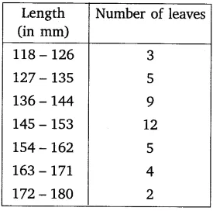

Find the median length of the leaves.

28. Area of a sector of a circle of radius 36 cm is 54π cm2. Find the length of the corresponding arc of the sector.

(OR)

Find the radius of a circle if an arc of angle 400 has length of 4π cm. Hence, find the area of the sector formed by this arc.

29. From a point on a bridge across a river, the angles of depression of the banks on opposite sides of the river are 30° and 45°, respectively. If the bridge is at a height of 3 m from the banks, find the width of the river.

(OR)

A straight highway leads to the foot of a tower. A man standing at the top of the tower observes a car at an angle of depression of 30°, which is approaching the foot of the tower with a uniform speed. Six seconds later, the angle of depression of the car is found to be 60°. Find the time taken by the car to reach the foot of the tower from this point.

30. If 1+ sin2 =3 sin cos , prove that tan = 1 or

31. In the figure PQ is a chord of length 8 cm of a circle of radius 5 cm. The tangents at P and Q intersect at a point T. Find the length TP.

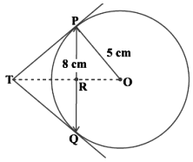

**Section-D**

**IV. Section D has 4 questions carrying 05 marks each.**

32. (i) Prove that + = 1 + sec $θ cosec θ .$

(ii) Prove that sin6 + cos6  = 1-3sin2cos2 .

(OR)

(i)If tan +sin = m and tan $θ$– sin n, show that m2 – n2 = 4 .

(ii) Express the trigonometric ratios sin A, sec A and tan A in terms of cot A.

33. Mode of the following frequency distribution is 65 and sum of all the frequencies is 70. Find the missing frequencies x and y. And also find the median.

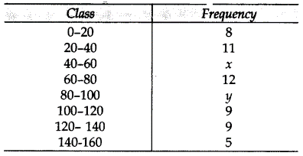

34. A solid consisting of a right circular cone of height 120 cm and radius 60 cm standing on a hemisphere of radius 60 cm is placed upright in a right circular cylinder full of water such that it touches the bottom. Find the volume of water left in the cylinder, if the radius of the cylinder is 60 cm and its height is 180 cm.

(or)

A solid iron pole consists of a cylinder of height 220 cm and base diameter 24 cm, which is surmounted by another cylinder of height 60 cm and radius 8 cm. Find the mass of the pole,

given that 1 cm3 of iron has approximately 8g mass.

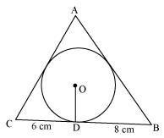35. In the given figure a triangle ABC is drawn to circumscribe a circle of radius 4 cm such that the segments BD and DC into which BC is divided by the point of contact D are of lengths 8 cm and 6 cm respectively. Find the sides AB and AC.

**Section-E**

**V.CASE BASED QUESTION.**

36. One evening, Kaushik was in a park. Children were playing cricket. Birds were singing on a nearby tree of height 80m. He observed a bird on the tree at an angle of elevation of 45°.

When a sixer was hit, a ball flew through the tree frightening the bird to fly away. In 2 seconds, he observed the bird flying at the same height at an angle of elevation of 30° and the ball flying towards him at the same height at an angle of elevation of 60°.

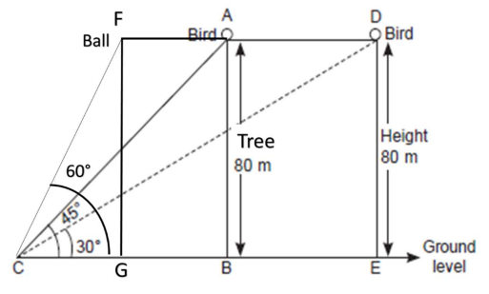

(i)At what distance from the foot of the tree was he observing the bird sitting on the tree?

(ii)What is the speed of the bird in m/min if it had flown 20(√3 + 1) m?

(iii) How far did the bird fly in the mentioned time?

(or)

After hitting the tree, how far did the ball travel in the sky when Kaushik saw the ball?

37. In a circle of radius 15 cm, an arc subtends an angle of 60° at the center. Find:

(i) the length of the arc.

(ii) area of the sector formed by the arc.

(iii) area of the segment formed by the corresponding chord.

(OR)

area of the major segment.

38.On Diwali festival, a big company decided to gift his employees an electric kettle which was in a shape of cylinder and gift wrapped in the cubical box. The dimension of box is 20 cm x 15 cm x 30 cm and the radius and height of electrical kettle are 14cm and 25 cm.



(i)Find the volume of the box.

(ii)Find the maximum length of the rod that can be kept in the box.

(iii)Find the area of the wrapping sheet that covers box exactly.

(OR)

Find the total surface area of an electric kettle.

***\*\*\* ALL THE BEST \*\*\****